Academic Classification Tree Analysis

An Assignment submitted in partial fulfillment of the requirements for the degree of
Bachelor of Science
in
Computer Science

CS 3306: Databases 2

Term 4 - 2025
University of The People

Instructor: Dr. Afrah Nazir

May 27th 2026

Academic Classification Tree Analysis
Introduction
Decision trees are powerful data mining tools designed to partition complex data into organized, manageable categories. Abstractly, the classification process uses past instances to predict the class of a new item based on its attributes, employing tree structures in which internal nodes evaluate predicates and leaf nodes represent final classifications (Silberschatz, Korth, & Sudarshan, 2001). Figure 22.6 demonstrates this methodology by using categorical and continuous variables to partition data and predict outcomes. This assignment applies these principles in an academic setting by constructing a classification tree to predict final course grades ranging from A to F.

Constructing the course grade classification tree
To predict a student's final grade, one can construct a tree using study habits as partitioning attributes. The root node of this tree is Study Hours Per Week. The tree branches into different levels of study time, which are then further partitioned based on Assignment Completion Quality. For instance, if a student spends a few hours studying and has low assignment quality, the tree directs the path to a leaf node categorized as an F. Conversely, more commitment to both study hours and assignment quality leads to higher grade classifications. The structure of the proposed grade classification tree is as follows:
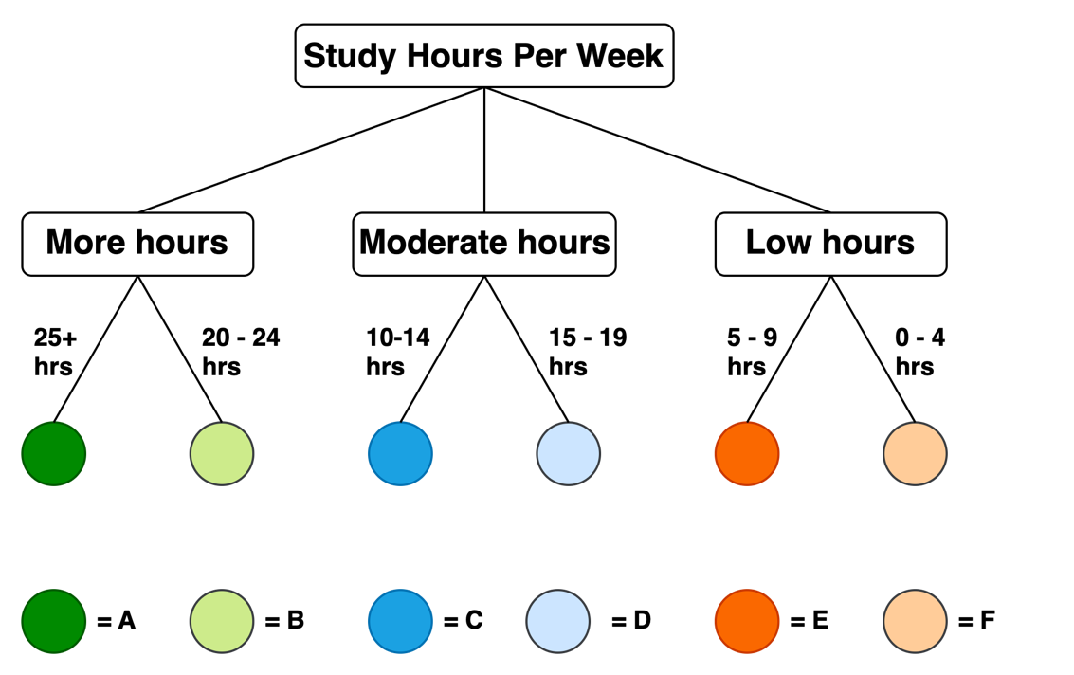

Identification of preferred grade classification
My preferred classification on this tree is the A grade. According to the logic established in the tree above, A's classification is reached via the High Hours branch, combined with Consistent Assignment Quality. For example, a student who dedicates more than sixteen hours weekly to course material and maintains a high standard of assignment quality will travel through these specific internal nodes to reach the leaf node labeled A. This outcome is preferred because it signifies mastery of the course content and demonstrates the diligent application of study resources throughout the semester.

The logic of decision tree construction
The effectiveness of these models relies on the greedy algorithm, which builds the tree by choosing the attribute and partitioning condition that results in the maximum information gain. When constructing the grade tree, one must evaluate which attribute, study hours or assignment quality, creates the purest partitions. If a node results in a mixture of grades, further partitioning is necessary until the leaf nodes represent distinct, predictable outcomes.
The process of finding the best split is essential for accuracy. In classification models, trees are optimized by evaluating the purity of the data at the children resulting from partitioning by a specific attribute (Silberschatz, Korth, & Sudarshan, 2001). In the academic tree, merging specific study-hour ranges makes the model more readable while maintaining its predictive power. By consistently applying these quantitative measures of purity, the model becomes a reliable roadmap for academic success.

Conclusion
Classification trees transform raw, often noisy data into structured decision support systems. By applying the methodologies outlined by Silberschatz, Korth, and Sudarshan (2001), this assignment demonstrated how variables such as study time and assignment quality can be used to accurately categorize student outcomes. By understanding the pathways that lead to an A, students gain actionable insights into how their daily decisions influence their final results. Whether applied to data mining or academic achievement, the decision tree remains a vital tool for turning branching data into a clear and predictable hierarchy of success.

Reference
Silberschatz, A., Korth, H.F., & Sudarshan, S. (2001). Database system concepts (4th ed.). New York, NY: McGraw-Hill.

